Poster

TITLE

Dark Personality as a Causal System: A Network Approach

ABSTRACT

The origin, development, and nature of maladaptive traits are oft discussed as latent traits (e.g,. narcissism) causing sets of interrelated behaviors (e.g., arrogance). In this paper, we propose an alternative, network perspective for conceptualizing dysfunctional tendencies as causal system of interlocking strategies. We demonstrate with item-level networks of the Dark Triad.

PRESS PARAGRAPH

Psychology has traditional treated normal and abnormal personal traits as conceptual entities that cause people to act in a similar way over time. Such traits are then treated as a basis for selection, training, and understanding of employee decisions. The current paper offers an alternative perspective that treats traits as bundles of mutually reinforcing acts. That is, traits arise from clusters of thoughts, feelings, and behaviors that become entangled over time. Such a view offers a more complicated – yet more realistic – understanding that better lends itself to coaching and training interventions.

WORD COUNT

2,964

What is the nature of psychopathy and narcissism? Many, if not all, research paradigms in psychology treat deviant traits as analogous to diseases existing as distinct entities *causing* outward actions such as meanness and self-promotion. However, this idea has been challenged by the emergence of a *network* perspective (Borsboom & Cramer, 2013). According to this approach, the ontological status of traits is shifted from causal entities divorced from their indicators to networks of interlocking acts that mutually reinforce one another. From this perspective, distrust and avoidance are not caused by the same underlying trait (i.e., paranoia) but causally influence one another (i.e., distrust 🡪 avoidance). A dysfunctional disposition, then, develops because of direct relations between complementary behaviors and thoughts in which feedback mechanisms are present: for example, perceived threat at work 🡪 distrust 🡪 avoidance 🡪 hypervigilance 🡪 perceived threat at work. These feedback mechanisms propel the aggravation of a leader’s suspicious tendencies by potentially transitioning a leader into full-blown skeptic. In the current paper, we elaborate upon a network perspective to personality disorders, review models consistent with this perspective, offer an empirical example with the Hogan Development Survey, and close with coaching implications. All R code needed to reproduce analyses are available upon request.

**Factor v. Network Conceptualization of Traits**

The dominant view of personality is that latent traits (e.g., neuroticism) cause human behavior as reflected in pattered responses to personality items (e.g., “I worry a lot” and “I am easily stressed”). However, the existence of latent ‘traits’ is easily challenged because (a) it is difficult to characterize latent variables independent of their indicators, (b) neuroscientific evidence suggests there is little one-to-one correspondence between neurological properties and psychological constructs, and (c) the behavioral states constituting traits are more dynamic, adaptive, and interactive than latent models assume (Borsboom & Cramer, 2013; Cramer et al., 2012).

Conversely, network analyses overcome reliance on local item independence (Cramer et al., 2012), model emergence of different personality structures across individuals, and reconcile social-cognitive and trait theories of personality (Furr, Fleeson, Anderson, & Arnold, 2012). The need for latent factors is waived by treating correlations between psychological variables as clusters which become tightly related through functional, causal, and homeostatic mechanisms. For instance, personality ‘traits’ are believed to emerge out of the connectivity between complementary thoughts, feelings, and behaviors (e.g., if one tends to not worry about things then they are less likely to experience stress). Figure 1 illustrates the distinction between latent and network perspectives[1].

From a network perspective, each maladaptive personality type can be seen as a similar system of interconnected functional cognitive, affective, and social units organized into relatively stable configurations along with their (joint) mediation of an individual’s behavior (Mischel & Schoda, 1995). Cramer and Borsboom (2015) state such syndromes might be understood as ‘problems attracting problems.’ For instance, a narcissists’ demand for attention (e.g., bragging) is often met by negative social reactions which, in turn, prompts hostility to defend a ‘shallow’ self-concept. Rather than embrace humility, narcissists seek new sources of positive feedback to sustain an inflated self-image (e.g., new management team). It is the dynamic of *self-promotion* followed by *self-protection* which explains how one kind of problem (e.g., grandiosity) creates another (e.g., social rejection and self-defensiveness; Back et al., 2013). When this cycle repeats itself, an enduring system of thoughts and actions is created which we observe and call narcissism.

The network approach carries multiple implications for understanding traits. First, individual differences are processes arising at the level of affective, cognitive, and behavioral components and the relations between them rather than at trait levels (see Figure 1). This permits generation of testable hypotheses about the organization, centrality, and trajectories of specific personality components which spur the development of maladaptive traits. Two, if we accept specific causal connections between behavioral problems are what constitute a “dysfunctional disposition,” then the term “comorbidity” gathers a different meaning: no longer is overlap explained as convergence between two sub-clinical traits, nor as the result of a common higher-order defense strategy (e.g., moving away; Hogan & Hogan, 2001). Finally, network analysis with longitudinal data permits modeling of *unique* intra-individual networks. We next explain network concepts and illustrates its application by exploring potential causal pathways giving rise to the Dark Triad (psychopathy, narcissism, and Machiavellianism).

**Methods**

**Sample and Measures**

Data were obtained from Hogan Assessment System’s Global Normative Dataset (HGND). The HGND is based upon a stratified random sample of over 150,000 working adults and job applicants classified according to the Department of Labor’s breakdown of jobs. Organizations include healthcare, military services, transportation, protective services, retail, manufacturing, and hospitality. A sub-set of 66,760 participants completing English versions of the Hogan Development Survey (HDS) were used in the analysis.

The HDS is a dichotomous 168-item self-report of maladaptive interpersonal strategies that interfere with occupational advancement. The 11 HDS scales target sub-clinical variants of the DSM IV Axis II disorders that fall into “every day” range of functioning. HDS scales of bold (e.g., “In time people will recognize my importance”), mischievousness (e.g., “Some laws were just meant to be broke”), and skepticism (e.g., “There are few people in life that you can really trust”) were treated as analogs of narcissism, psychopathy, and Machiavellianism. This is supported by mapping of scale content across dark side models (Spain, Harms, & LeBreton, 2013) and convergent validation with normative measures of the dark triad (Ferrell & Gaddis, 2016; Spain, Harms, & LeBreton, 2013). The HDS technical manual reports 9-month test-retest reliabilities ranging from .55 for Skeptical to .68 for Mischievous (Hogan & Hogan, 2009).

**Network Analyses**

A network is an abstract model composed of nodes, edges that connect nodes, and information concerning the nature of the nodes and edges. The nodes represent items (or ‘components’) while edges represent their pairwise associations. Personality networks are both *weighted* and *signed*, therefore it is important to distinguish large from small and positive from negative associations.All network analyses were generated using the *qgraph* (Epskamp, Cramer, Waldorp, Schmittmann, & Borsboom, 2012) and the network analytic approach primarily follows the procedures from Constantini et al. (2015). This included calculating metrics to examine the *global* structure (whether it features strong clusters, or “small-world” structure), and *local* patterns within the network (which nodes are most central and strongly correlated).

**Network generation and descriptive properties.**  Since all items are binary they were first transformed into a *polychoric* correlation matrix. We generated three association networks–the correlation and partial correlation network, and one item-level adaptive least absolute and shrinkage and selection operator (LASSO) network (Zou, 2006). The *qgraph* package implements Fruchterman and Reingold’s (1991) algorithm, which positions strongly correlated nodes near the center of the network and weakly correlated nodes near the periphery. Partial correlations are preferable for extracting plausible causal networks because they represent the association between two variables after controlling for the effects of all other variables; in other words, they provide a more accurate portrayal of true associations between variables by reducing spurious connections (Costantini et al., 2015). However, partial correlation networks often remain fully saturated despite the likelihood small associations are virtually indistinguishable from zero. To identify an optimal model, a graphical least absolute shrinkage and selection operators (LASSO; Friedman, Hastie, & Tibshirani, 2008; Tibshirani, 1996) regularization is applied. The graphical LASSO estimates a penalized maximum likelihood solution in which the likelihood is penalized for the sum of absolute parameter estimates. As a result, the graphical LASSO estimate still explains the data well with generally weaker parameter estimates set to zero. If an edge is present in the graphical LASSO, one can assume a relationship exists between the variables in question.

**Global Patterns.** To examine global network structure, we calculated metrics for transitivity and the small-world index. Transitivity determines if clustering is a property of the global network and compares the density of connected triangles to that of a random network with the same number of vertices and edges (Newman, 2003; Opsahl & Panzarasa, 2009). Small-world property networks have high clustering coefficient with short path length, meaning that most nodes whether or not they are part of the same local cluster, are connected by a short path (Newman, 2003; Watts & Strogatz, 1998); values between one and three are considered to be borderline, and values over three to reflect a small-world property (Humphries & Gurney, 2008).

**Local Patterns.** To examine the importance of individual nodes and determine how quickly nodes influence each other, we calculated three indices of centrality: strength, closeness, and betweenness (Freeman, 1978). Strength is the sum of the weights of all edges connected to a given node. Closeness is the inverse of the sum of the distances of a given node from all other nodes in the network. Betweenness is the number of times that the shortest path between two nodes passes through a given node. Higher values on each index reflect greater centrality in the network. We also include multiple *clustering coefficients,* which is the number of connections among neighbors of a node over the maximum possible number of such connections (Watts & Strogatz, 1998). If a node has a high clustering coefficient, its neighbors are connected with each other, therefore that node is not necessary for its neighbors to reach or to influence each other and can be considered redundant (Constantini & Perugini, 2014).

**Results**

The networks generated for illustrative purposes are displayed in Figure 2. In the top panel, the interitem correlation matrix with node placement by items of the HDS shows a structure difficult to detect with conventional factor analyses. One, a majority of the components tend to be loosely organized within the purported three dark traits with certain subsets more strongly interrelated than others. Two, several mischievous components (mis11, mis2, mis3, and mis14) appear better embedded within or between other network components. Three, several bold (bol1, bol2, bol4, bol9) and skepticism (ske9, ske7, ske8, and ske14) components help to explain interconnectivity or overlap between the respective dark triad traits. The partial correlation matrix displayed in the middle shows that, once controlling for the effects of all other items, several edges disappear and many negative correlations emerge involving ske with certain bol and mis items. Further, unique connections between several components become more pronounced suggesting local facet structures within each network.

The most informative results emerge in the LASSO model. Network descriptive statistics show the adaptive LASSO network had 345 edges (306 positive and 39 negative) out of 861 possible connections; 60% of the connections were deemed to be near-zero or not significant. A *t* test comparing average weights of positive versus negative edges was significant (*t* = 2.44, *df* = 343, *p* = .02), suggesting the mean weight edges of positive values (*M* = .05) are stronger than negative edges (*M* = .03). The partial correlation matrix upon which the item-level adaptive LASSO network was based is displayed in Table 2.

Visual inspection of the final network indicates the strongest edges tend to be within traits suggesting mutually reinforcing systems of thoughts and actions. For instance, holding strong hostile attributions (ske 5, ske 6, ske 1) is likely to promote general mistrust of others (ske3, ske2, ske4), believing oneself to be exceptional (bol5, bol7) will motivate a desire to show off and be praised (bol2, bol6, bol11), and the tendency to take risks (mis4) appears to be a central component activating impulsivity (mis1), dangerous activities (mis5, mis6), and manipulation (mis9, mis10).

Another insight is the potential “bridge” components linking distinct traits of the triad. For instance, believing modesty hurts advancement (bol9) links the Machiavellic’s general distrust of politicians and institutions (ske4, ske10) with the psychopath’s willingness to break laws and exploit other’s mistakes (mis8, mis12). Hence, Dark Triad covariation may arise through a distrust 🡨🡪 immodesty 🡨🡪 rule breaking chain*;* for instance, distrust may *lead* to more rule breaking via the belief one should over-represent their finer qualities. Similarly, heightened overconfidence (bol14, bol10, bol13) is indirectly linked to the risk taking (mis6) and conniving (mis9, mis10) via turning on the “charm” (mis13). Manipulation as a potential bridge between narcissism and psychopathy is unsurprising as interpersonal exploitation is needed to gain praise (narcissism) and bend rules (psychopathy). Finally, believing one is great (bol5, bol7) appears to *lower* resentment (ske 11, ske12) because being great requires letting go of past mistakes (mis2, mis3), including rivalries. At the same time, a narcissist’s need for recognition (bol1, bol3, bol4) is *positively* connected to the willingness to take aggressive social actions to restore justice (ske 9, ske 7). This suggests countervailing effect in which some elements of narcissism activate growth in Machiavellianism whereas others diminish it.

**Network Properties for Item-Level Adaptive Lasso Network**

**Global Structure.** Network transivity and average path length (.47, 1.61) were slightly larger than values of similar random networks (.42. 1.60). The small-world value for the adaptive LASSO network was 1.12, which is a borderline value for small-world property. Together, these results suggest slightly higher transitivity, indicating an increased probability of a connection between two nodes with a common neighbor. However, the larger average path values and lack of small-world supports the idea that different dark triad traits represent distinct yet interconnected systems (Constantini et al., 2015).

**Local Patterns.** The centrality indices for network nodes are displayed in Figure 3. Eight nodes consistently had one of the top six ratings on all three centrality indices. These included items: Ske10, “People who are in charge will take advantage of you if you let them”; ske8, “No one gets to take advantage of me more than once”; mis4, “I enjoy taking risks”; mis7, “Life is no fun if you play it safe”; bol13, “I have a natural talent for leadership.”; bol10, “People can often sense my power”; bol7, “I am very good at almost everything I do”; and bol3, “I insist on receiving the respect that I am due”. This suggests a sense of invincibility, vindictiveness, and risk taking play central roles in maintaining connectivity within the Dark Triad. In contrast, multiple items (bol4, 8; mis 1, 3, 5; ske 5, 6, 12) had low rankings on multiple centrality indices, suggesting they exert little influence on the Dark Triad network. Interestingly, many of these items are more action- (“do things in spur of the moment) or past-oriented (“never worry about past mistakes”) suggesting behavioral residual which emanates from the central motivational and self-evaluate components of the Dark Triad. Local clustering coefficients are displayed in Figure 4. Low clustering coefficients coupled with low centrality indices indicate weak items within the overall network. Specifically, items showing suspicion or skill (e.g., ske6, ske5, mis11, bol12) appear redundant and do little to influence the strength or connectivity of the network.

**Conclusions**

This study applied the network analysis to various items constituting the Dark Triad. It investigated the topological properties and “bridges” between traits and identified the most central and redundant nodes and edges. Several pathways and components that appear particularly central to the Dark Triad’s connectivity were revealed. There are several coaching implications from the network analysis.

**Coaching Implications**

The network perspective shifts “latent dysfunctions” to unique relations between targeted problem behaviors. Because there is no evidence all people elevated on a particular scale share an essential property on a labeled trait, improving a “categorical” personality disorder is hypothetical. Thus, interventions would, target symptoms themselves or the causal relations that connect them, rather than treating ‘problematic personalities.’

Second, a network perspective pinpoints targets for coaching by identifying components with high centrality in a causal system. Turning off active behaviors with outgoing edges allows for the deactivation of other problematic behaviors (Cramer et al., 2012). For example, current data suggests enjoyment of risks, deep-seated distrust, and fantasizing about talent are central components to maintaining the “antagonistic” core of the Dark Triad (Paulhus & Williams., 2002). Accordingly, coaches may aim to build a trusting attitudes before initializing cognitive or “self” work to reduce levels of grandiosity. Likewise, behaviorally oriented interventions could modify or ‘craft’ the context to both reduce incentives and raise consequences for risk taking. Success in doing so may be necessary to deactivate motives to be ‘exceptional’ because risk opportunities likely strengthen the links between mischievous and bold tendencies.

Third, central behaviors are more intractable due to their dependency on multiple components. For example, changing the need for others’ respect may be difficult because it requires first changing peripheral components (retaliatory schema and exaggerated confidence). If too many peripheral issues are addressed, potential gains may be minimal; conversely, if *only* central components are targeted, little behavioral change may occur. Consequentially, coaches could target combinations of peripheral and central components.

The final implication is identification of the social and environmental factors that maintain ‘behavioral equilibrium’ between aversive behaviors. For instance, people often seek out environments that match their behavioral repertoire (Heady & Wearing, 1989). Narcissists find stages, psychopaths find opportunities, and so forth. These situations afford feedback loops which sustain a dark trait while, at the same time, suppressing opposing actions. For example, a narcissist cannot both occupy the stage while also shining the spotlights on others. To be humble requires an environment of giving; however, narcissists are unlikely to occupy roles demanding such behaviors making such change difficult. Differences in network structure and node centrality across work contexts could be used by coaches to identify ‘problematic situations’ that may be inadvertently encouraging cascades of bad thoughts and actions within the ranks.

**References**

Back, M. D., Küfner, A. P., Dufner, M., Gerlach, T. M., Rauthmann, J. F., & Denissen, J. A. (2013). Narcissistic admiration and rivalry: Disentangling the bright and dark sides of narcissism. *Journal of Personality And Social Psychology*, *105*(6), 1013-1037. doi:10.1037/a0034431

Borsboom, D., & Cramer, A. J. (2013). Network analysis: An integrative approach to the structure of psychopathology. *Annual Review of Clinical Psychology*, *9,* 91-121. doi:10.1146/annurev-clinpsy-050212-185608

Costantini, G., Epskamp, S., Borsboom, D., Perugini, M., Mõttus, R., Waldorp, L. J., & Cramer, A. O. (2015). State of the aRt personality research: A tutorial on network analysis of personality data in R. *Journal of Research in Personality, 54*, 13-29.

Costantini, G., & Perugini, M. (2014). Generalization of clustering coefficients to signed correlation networks. *PloS one*, *9*(2), e88669.

Cramer, A. O., Sluis, S., Noordhof, A., Wichers, M., Geschwind, N., Aggen, S. H., ... & Borsboom, D. (2012). Dimensions of normal personality as networks in search of equilibrium: You can't like parties if you don't like people. *European Journal of Personality, 26*(4), 414–431.

Cramer, A. O. J., & Borsboom, D. (2015). Problems attract problems: A network perspective on mental disorders. In R. A. Scott & S. M. Kosslyn (Eds.), *Emerging trends in the social and behavioral sciences: An Interdisciplinary, searchable, and linkable resource* (pp. 1 – 15). New York: Wiley.

Epskamp, S., Cramer, A., Waldorp, L., Schmittmann, V., & Borsboom, D. (2012). qgraph: Network visualizations of relationships in psychometric data. *Journal of Statistical Software, 48*(4), 1 - 18. doi:<http://dx.doi.org/10.18637/jss.v048.i04>.

Ferrell, B., & Gaddis, B. (2016). *How well does the dark triad capture dark side personality?* Poster presented at the 31st annual meeting for the Society for Industrial and Organizational Psychology, Anaheim, CA.

Freeman, L. C. (1978). Centrality in social networks conceptual clarification. *Social networks*, *1*(3), 215-239.

Friedman, J., Hastie, T., & Tibshirani, R. (2008). Sparse inverse covariance estimation with the graphical lasso. *Biostatistics*, *9*(3), 432-441.

Fruchterman, T. M., & Reingold, E. M. (1991). Graph drawing by force‐directed placement. *Software: Practice and experience*, *21*(11), 1129-1164.

Furr, R. M., Fleeson, W., Anderson, M., & Arnold, E. M. (2012). On the contributions of a network approach to personality theory and research. *European Journal of Personality*, *26*(4), 437-439.

Heady, B., & Wearing, A. (1989). Personality, life events, and subjective well-being: toward a dynamic equilibrium model. *Journal of Personality and Social Psychology, 57*, 731–739.

Hogan, R., & Hogan, J. (2001). Assessing leadership: A view from the dark side. *International Journal of Selection And Assessment*, *9*, 40-51. doi:10.1111/1468-2389.00162

Hogan, R., & Hogan, J. (2009). *Hogan development survey manual* (2nd Ed.). Tulsa, OK: Hogan Assessment Systems.

Humphries, M. D., & Gurney, K. (2008). Network ‘small-world-ness’: a quantitative method for determining canonical network equivalence. *PloS one*, *3*(4), e0002051.

Mischel, W., & Shoda, Y. (1995). A cognitive-affective system theory of personality: Reconceptualizing situations, dispositions, dynamics, and invariance in personality structure. *Psychological Review*, *102*(2), 246-268. doi:10.1037/0033-295X.102.2.246

Newman, M. E. (2003). The structure and function of complex networks. *SIAM review*, *45*(2), 167-256.

Opsahl, T., & Panzarasa, P. (2009). Clustering in weighted networks. *Social networks*, *31*(2), 155-163.

Paulhus, D. L., & Williams, K. M. (2002). The Dark Triad of personality: Narcissism, Machiavellianism and psychopathy. *Journal of Research in Personality*, *36*(6), 556-563. doi:10.1016/S0092-6566(02)00505-6

Spain, S. M., Harms, P., & LeBreton, J. M. (2014). The dark side of personality at work. *Journal of Organizational Behavior*, *35*, 41-60. doi:10.1002/job.1894

Tibshirani, R. (1996). Regression shrinkage and selection via the lasso. *Journal of the Royal Statistical Society. Series B (Methodological)*, 267-288.

Watts, D. J., & Strogatz, S. H. (1998). Collective dynamics of ‘small-world’ networks. *Nature*, *393*, 440-442.

Zou, H. (2006). The adaptive lasso and its oracle properties. *Journal of the American Statistical Association*, *101*(476), 1418-1429.

|  |  |  |  |  |  |  |  |  |  |  |  |  |  |  |  |  |  |  |  |  |  |  |  |  |  |  |  |  |  |  |  |  |  |  |  |  |  |  |  |  |  |  |
| --- | --- | --- | --- | --- | --- | --- | --- | --- | --- | --- | --- | --- | --- | --- | --- | --- | --- | --- | --- | --- | --- | --- | --- | --- | --- | --- | --- | --- | --- | --- | --- | --- | --- | --- | --- | --- | --- | --- | --- | --- | --- | --- |
| **Item** | 1 | 2 | 3 | 4 | 5 | 6 | 7 | 8 | 9 | 10 | 11 | 12 | 13 | 14 | 15 | 16 | 17 | 18 | 19 | 20 | 21 | 22 | 23 | 24 | 25 | 26 | 27 | 28 | 29 | 30 | 31 | 32 | 33 | 34 | 35 | 36 | 37 | 38 | 39 | 40 | 41 | 42 |
| 1. bol1 |  |  |  |  |  |  |  |  |  |  |  |  |  |  |  |  |  |  |  |  |  |  |  |  |  |  |  |  |  |  |  |  |  |  |  |  |  |  |  |  |  |  |
| 2. bol2 | .07 |  |  |  |  |  |  |  |  |  |  |  |  |  |  |  |  |  |  |  |  |  |  |  |  |  |  |  |  |  |  |  |  |  |  |  |  |  |  |  |  |  |
| 3. bol3 | .14 | .09 |  |  |  |  |  |  |  |  |  |  |  |  |  |  |  |  |  |  |  |  |  |  |  |  |  |  |  |  |  |  |  |  |  |  |  |  |  |  |  |  |
| 4. bol4 | .08 | -- | .07 |  |  |  |  |  |  |  |  |  |  |  |  |  |  |  |  |  |  |  |  |  |  |  |  |  |  |  |  |  |  |  |  |  |  |  |  |  |  |  |
| 5. bol5 | -- | -- | -- | .01 |  |  |  |  |  |  |  |  |  |  |  |  |  |  |  |  |  |  |  |  |  |  |  |  |  |  |  |  |  |  |  |  |  |  |  |  |  |  |
| 6. bol6 | .01 | .04 | -- | .03 | .09 |  |  |  |  |  |  |  |  |  |  |  |  |  |  |  |  |  |  |  |  |  |  |  |  |  |  |  |  |  |  |  |  |  |  |  |  |  |
| 7. bol7 | -- | .03 | .01 | -- | .33 | .20 |  |  |  |  |  |  |  |  |  |  |  |  |  |  |  |  |  |  |  |  |  |  |  |  |  |  |  |  |  |  |  |  |  |  |  |  |
| 8. bol8 | -- | .03 | -- | -- | -- | -- | .05 |  |  |  |  |  |  |  |  |  |  |  |  |  |  |  |  |  |  |  |  |  |  |  |  |  |  |  |  |  |  |  |  |  |  |  |
| 9. bol9 | .06 | -- | .05 | .06 | .01 | .02 | -- | -- |  |  |  |  |  |  |  |  |  |  |  |  |  |  |  |  |  |  |  |  |  |  |  |  |  |  |  |  |  |  |  |  |  |  |
| 10. bol10 | .05 | .09 | .08 | -- | .02 | .10 | .02 | -- | .01 |  |  |  |  |  |  |  |  |  |  |  |  |  |  |  |  |  |  |  |  |  |  |  |  |  |  |  |  |  |  |  |  |  |
| 11. bol11 | .03 | .13 | -- | -- | -- | .02 | .05 | .06 | -- | .04 |  |  |  |  |  |  |  |  |  |  |  |  |  |  |  |  |  |  |  |  |  |  |  |  |  |  |  |  |  |  |  |  |
| 12. bol12 | -- | -- | -- | -- | -- | .02 | -- | .05 | -- | .05 | .05 |  |  |  |  |  |  |  |  |  |  |  |  |  |  |  |  |  |  |  |  |  |  |  |  |  |  |  |  |  |  |  |
| 13. bol13 | -- | -- | -- | -- | -- | -- | .10 | .08 | -.01 | .12 | .05 | .09 |  |  |  |  |  |  |  |  |  |  |  |  |  |  |  |  |  |  |  |  |  |  |  |  |  |  |  |  |  |  |
| 14. bol14 | -- | .10 | -- | .01 | -- | .10 | -- | .03 | -- | .07 | -- | .02 | .04 |  |  |  |  |  |  |  |  |  |  |  |  |  |  |  |  |  |  |  |  |  |  |  |  |  |  |  |  |  |
| 15. mis1 | -- | -- | -- | -- | -- | -- | -- | .01 | -- | -- | -- | -- | -- | -- |  |  |  |  |  |  |  |  |  |  |  |  |  |  |  |  |  |  |  |  |  |  |  |  |  |  |  |  |
| 16. mis2 | -.02 | -- | .02 | .01 | .07 | -- | .03 | -- | -- | -- | -.01 | -- | -- | -- | -.01 |  |  |  |  |  |  |  |  |  |  |  |  |  |  |  |  |  |  |  |  |  |  |  |  |  |  |  |
| 17. mis3 | -.07 | -- | -- | .02 | .04 | -- | -- | -- | .01 | .01 | -- | -- | -- | .02 | -- | .19 |  |  |  |  |  |  |  |  |  |  |  |  |  |  |  |  |  |  |  |  |  |  |  |  |  |  |
| 18. mis4 | -- | -- | -- | -- | -- | -- | -- | .06 | -- | .05 | -- | .03 | .11 | .02 | .18 | -- | .03 |  |  |  |  |  |  |  |  |  |  |  |  |  |  |  |  |  |  |  |  |  |  |  |  |  |
| 19. mis5 | -- | -- | -- | -- | -- | -- | -- | -- | -- | -- | -- | -- | -- | -- | .04 | -- | -- | .10 |  |  |  |  |  |  |  |  |  |  |  |  |  |  |  |  |  |  |  |  |  |  |  |  |
| 20. mis6 | -.04 | -- | -.06 | -- | .01 | .05 | -- | -- | -- | -- | -- | -- | -- | .12 | -- | -- | .01 | .08 | .25 |  |  |  |  |  |  |  |  |  |  |  |  |  |  |  |  |  |  |  |  |  |  |  |
| 21. mis7 | .04 | -- | -- | .03 | -- | -- | -.01 | -- | .09 | .01 | -- | -- | -- | -- | .09 | -.02 | .02 | .23 | .03 | .03 |  |  |  |  |  |  |  |  |  |  |  |  |  |  |  |  |  |  |  |  |  |  |
| 22. mis8 | .01 | -- | -- | -- | -- | -- | -.03 | -- | .02 | -- | -- | -- | -.03 | .01 | .05 | -.02 | -- | .01 | .02 | -- | .17 |  |  |  |  |  |  |  |  |  |  |  |  |  |  |  |  |  |  |  |  |  |
| 23. mis9 | .01 | -- | -- | -- | -- | .02 | -- | .02 | .01 | .07 | -- | .01 | .04 | .03 | .04 | -- | -- | .02 | -- | -- | -- | -- |  |  |  |  |  |  |  |  |  |  |  |  |  |  |  |  |  |  |  |  |
| 24. mis10 | -.06 | -- | -- | -.01 | -- | .04 | -- | .02 | -- | -- | -- | -- | -- | .02 | .02 | -- | -- | -- | .02 | .07 | -- | .04 | .23 |  |  |  |  |  |  |  |  |  |  |  |  |  |  |  |  |  |  |  |
| 25. mis11 | -- | .01 | -- | -- | .02 | -- | .03 | -- | -- | .04 | -- | .30 | .08 | .01 | -- | -- | -- | .03 | -- | -- | -- | -- | -- | -- |  |  |  |  |  |  |  |  |  |  |  |  |  |  |  |  |  |  |
| 26. mis12 | -- | -- | -- | .02 | -- | .04 | -- | -- | -- | -- | -- | -- | -- | -- | -- | -- | -- | -- | -- | .03 | -- | .06 | .01 | .05 | -- |  |  |  |  |  |  |  |  |  |  |  |  |  |  |  |  |  |
| 27. mis13 | .06 | -- | -- | .02 | .02 | -- | -- | -- | -- | .09 | -- | .09 | .05 | -- | .04 | -- | -- | .01 | .03 | -- | .03 | .04 | .13 | .10 | .10 | .05 |  |  |  |  |  |  |  |  |  |  |  |  |  |  |  |  |
| 28. mis14 | -- | -- | -- | -- | -- | .03 | -- | -- | .01 | -- | .01 | -- | -- | -- | .03 | -.07 | -- | -- | -- | -- | -- | .03 | -- | -- | -- | .01 | .03 |  |  |  |  |  |  |  |  |  |  |  |  |  |  |  |
| 29. ske1 | -- | -- | -- | -- | -- | .01 | -- | -- | -- | -- | -- | -- | -- | -- | -- | -- | -- | -- | -- | .01 | -- | -- | -- | .02 | -- | -- | -- | .05 |  |  |  |  |  |  |  |  |  |  |  |  |  |  |
| 30. ske2 | -- | -- | .04 | -- | .02 | -- | -- | -- | .02 | -- | -- | -- | -- | -- | -- | -- | -- | -- | -- | -- | -- | -- | -- | -- | -- | -- | -- | .14 | .07 |  |  |  |  |  |  |  |  |  |  |  |  |  |
| 31. ske3 | -.03 | -.02 | -- | -- | -- | -- | -.03 | -- | -- | -- | -- | -- | -- | -- | -- | -- | -- | -- | -- | -- | -- | -- | -- | .04 | -- | -- | -- | .05 | .08 | .27 |  |  |  |  |  |  |  |  |  |  |  |  |
| 32. ske4 | -- | .04 | -- | -- | -- | .01 | -- | -- | .02 | -- | -- | -- | -- | -- | .02 | -.02 | -- | -.01 | -- | -- | .01 | .05 | -- | -- | -- | -- | -- | .13 | -- | .08 | -- |  |  |  |  |  |  |  |  |  |  |  |
| 33. ske5 | .01 | -- | -- | -- | -- | -- | -- | -- | -- | -- | -- | -- | -- | -- | -- | -- | -- | -- | -- | -- | -- | -- | -- | -- | -- | .03 | -- | .05 | .36 | .05 | -- | -- |  |  |  |  |  |  |  |  |  |  |
| 34. ske6 | -- | -- | -- | -- | -- | -- | -- | -- | .01 | -- | -- | -- | -- | -- | -- | -- | -- | -- | -- | -- | -- | .01 | .01 | -- | -- | .04 | -- | .04 | .14 | .05 | .03 | -- | .16 |  |  |  |  |  |  |  |  |  |
| 35. ske7 | -- | .03 | .04 | -- | -- | -- | -- | -- | .01 | -- | .02 | -- | -- | .06 | -- | -.03 | -- | -- | -- | .03 | .07 | .02 | -- | .01 | -- | -- | .03 | .04 | -- | .02 | -- | .07 | .01 | -- |  |  |  |  |  |  |  |  |
| 36. ske8 | -.02 | -- | .10 | .06 | .04 | -- | .03 | -- | .03 | -- | -- | .01 | .02 | .05 | -.02 | .06 | .05 | -- | .01 | .01 | .01 | -- | -- | -- | .07 | -- | .02 | -- | -- | .04 | -- | .05 | -- | -- | .06 |  |  |  |  |  |  |  |
| 37. ske9 | -- | .01 | .12 | .02 | -- | -- | -- | -- | -- | -- | -- | -- | -- | .07 | -- | .03 | .01 | -- | .02 | .01 | -.02 | -- | .02 | .05 | -- | .03 | .01 | -- | -- | .03 | -- | -- | -- | .03 | .07 | .06 |  |  |  |  |  |  |
| 38. ske10 | -- | .06 | .05 | .01 | -- | -- | -- | -- | .08 | -- | -- | -- | -.05 | -- | -- | -- | -- | -.01 | -- | -- | -- | .05 | -- | -- | -- | .06 | -- | .13 | .05 | .13 | -- | .07 | .07 | .07 | .05 | -- | .06 |  |  |  |  |  |
| 39. ske11 | .05 | -- | -- | -- | -.02 | -- | -- | -- | -- | -- | -- | -.02 | -.01 | -.01 | -- | -.05 | -.10 | -.01 | -- | -- | -- | .04 | -- | .01 | -- | -- | -- | .03 | .03 | -- | .07 | -- | -- | -- | -- | -- | -- | .01 |  |  |  |  |
| 40. ske12 | .02 | -- | -- | -- | -- | -- | -- | -- | .01 | .05 | -- | -- | -- | -- | -- | -.04 | -- | -- | -- | -- | -- | .04 | -- | -- | -- | -- | -- | .01 | -- | -- | .01 | -- | -- | .04 | -- | -.04 | -- | .03 | .04 |  |  |  |
| 41. ske13 | -- | -- | -- | .03 | -- | -- | -- | -- | .02 | -- | -- | -- | -- | -- | -- | -.04 | -- | -- | -- | -- | -- | .03 | -- | -- | -- | -- | -- | .03 | .02 | .05 | .02 | -- | -- | -- | .01 | .02 | .02 | .01 | .25 | .08 |  |  |
| 42. ske14 | -- | .03 | .03 | -- | -- | -- | .01 | -- | -- | .04 | -- | .06 | -- | .01 | -- | -- | -- | -- | -- | -- | -- | -- | -- | .03 | .09 | .02 | .07 | -- | -- | .01 | .01 | -- | -- | -- | .04 | .09 | .01 | -- | .01 | .09 | .06 |  |

Table 2.

*Partial Correlation Matrix Estimated Through Generation of the Item-Level Adaptive LASSO Network*

Worries a lot

Tend to feel blue

Easily upset

Worries a lot

Tend to feel blue

Easily upset

**Figure 1.** Illustration of trait view according to a traditional latent variable (left panel) and a network perspective (right panel). From a latent perspective, a trait such as neuroticism is a common cause of stable dispositions that, together with transient factors, explain momentary states. The network alternative views direction interactions between personality components, influenced by transient states, as the source of synchronized stability of components. In this view, a trait such as neuroticism emerges out of these interactions. Trait are no longer common causes but summary statistics or index variables describing the average activation of personality states.

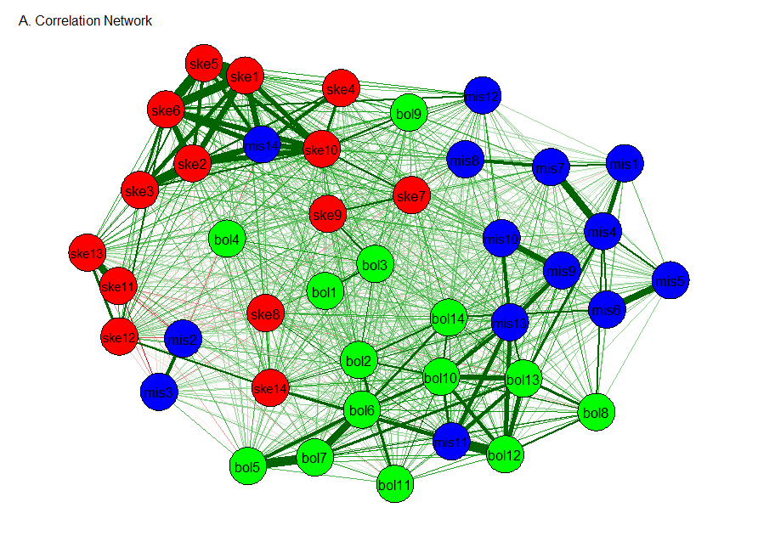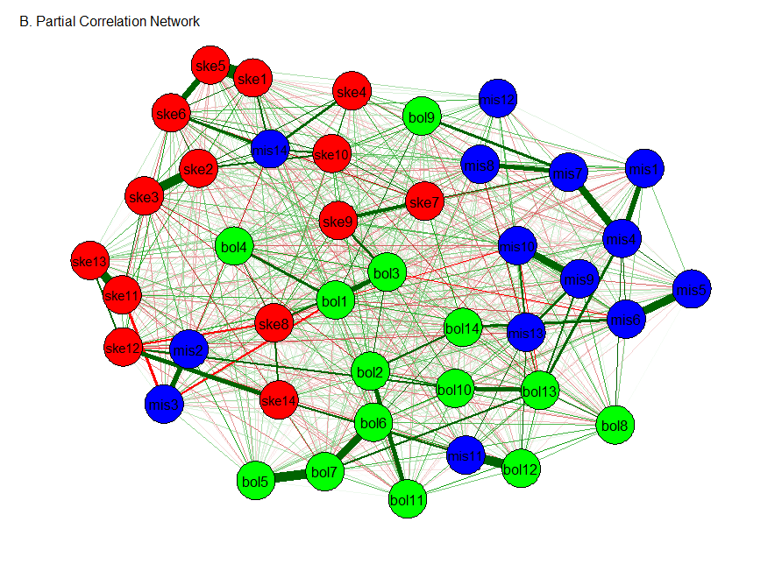

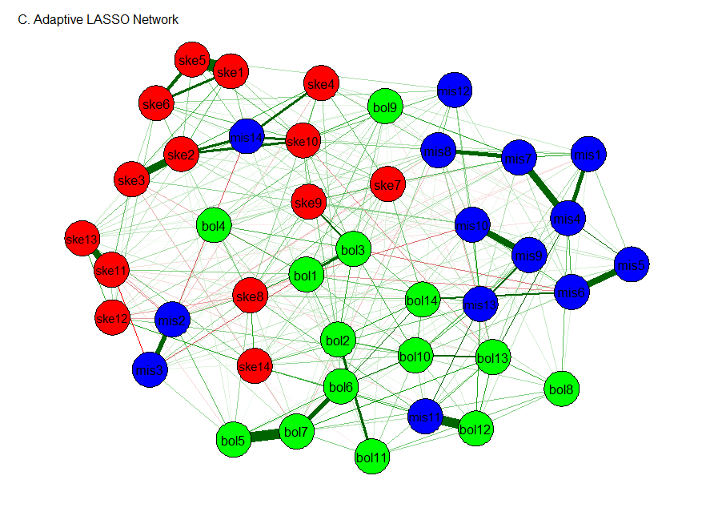

**Figure 2.** Networks of the HDS-42 Dark Triad. Nodes represent personality items (abbreviated descriptions of items are provided in Table 1). Red nodes correspond to Machiavellianism (i.e., skepticism), green nodes correspond to narcissism (i.e., bold), and blue nodes correspond to psychoticism (i.e., mischievous). Green lines represent positive connections and red lines represent negative connections. Thicker lines represent stronger connection and thinner lines represent weaker connections. The node placement of all graphs is based on the adaptive LASSO network (last one) to facilitate comparison. The width and color are scaled to the strongest edge and not comparable between graphs; edge strengths in the correlation network are generally stronger than the edge strengths in the partial correlation network.



**Figure 3.** Centrality plot for concentration (partial correlation) network depicting the betweenness, closeness, and strength of each node.



**Figure 4.** Clustering plot for concentration (partial correlation) network depicting 4 alternative coefficients.

1. We note both approaches seek to account for the same correlation matrix. The factor model does so by postulating the presence of unseen traits. However, we never observe narcissism or paranoia; all we have is a pattern of higher correlations among self-reported thoughts and behaviors. Without compelling evidence for the independent existence of a latent variable, we might avoid a reification fallacy and search for alternative interpretations.